Task 3 Report

Healthcare System

**Tasks Description :**

* **Task 1 :** is responsible to read the UART messages that has been sent by touch LCD and process its data
* **Task 2 :** is responsible to take an action on alert siren based on the three sensors readings
* **Task 3 :** is responsible to read the Blood pressure sensor and process its data
* **Task 4 :** is responsible to read the Heartbeat detector and process its data
* **Task 5 :** is responsible to read the Temperature sensor and process its data

**Task 1** | Priority : 1 Periodicity : 100 Execution : 2 Deadline : 100

**Task 2** | Priority : 2 Periodicity : 10 Execution : 1 Deadline : 10

**Task 3** | Priority : 5 Periodicity : 20 Execution : 3 Deadline : 20

**Task 4** | Priority : 3 Periodicity : 100 Execution : 1.5 Deadline : 100

**Task 5** | Priority : 4 Periodicity : 10 Execution : 2.5 Deadline : 10

**System tick rate : 10 ms**

**Hyper period : 100 ms**

**CPU load : $\frac{( 2 ) + \left( 1 * 10 \right) + \left( 5 * 3 \right) + \left( 1.5 \right) + ( 2.5 * 10 )}{100}$ = 0.535 = 53% ( Verified )**

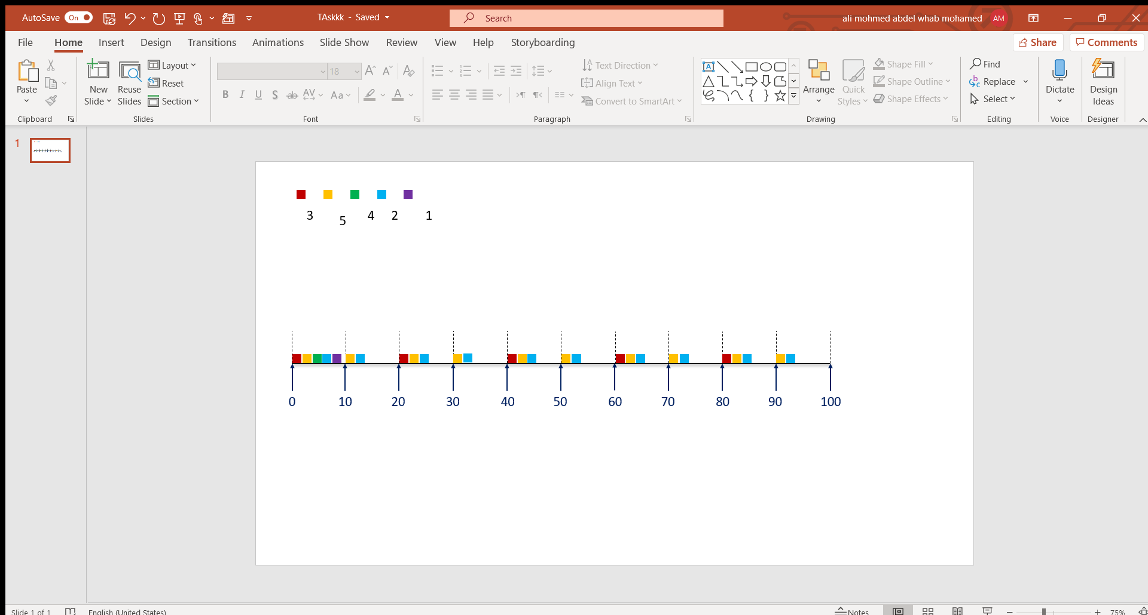 **Task 1**  **Task 2 Task 3 Task 4 Task 5**

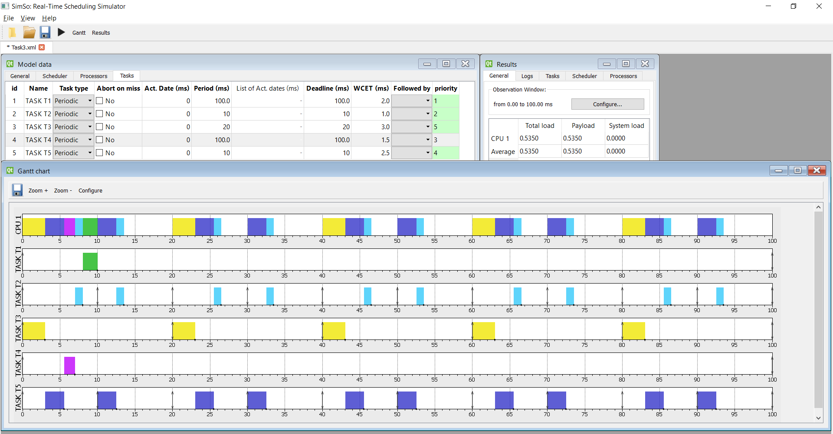

**In Task 1** I assumed that user would press on the LCD every 100 ms

So, it will read and process the data after 8 ms from pressed time

**In Task 2** I assumed that it would need to be executed every 10 ms based on task 4 ( Heartbeat detector ) if the sensor reading is above the normal and its priority ( 2 ) is lower than Task 5 ( 4 ) so task 4 will be executed first

**In Task 3** the Blood pressure sensor has new data every 25 ms so I made it with periodicity 20 ms to be a multiple of system tick rate(10) and give it the highest priority to be executed first every 20 ms as you can see here it will not miss any new reading of the sensor

Sometimes it will read it two times like here, but it will not miss it

**In Task 4** Heartbeat detector has new data every 100 ms so I do not need to read it every tick, so I gave it periodicity 100

**In Task 5** temperature sensor has new data every 10 ms so I gave it priority (4) to be first task to be executed before task 2 ( alert siren ) to make alert response faster so it will take the action based on new reading from task 5

**Comments**

*Task 1 can be event driven because we cannot predict when the user would press on it

*Task 2 can be event driven to decrease the CPU load , so it would be scheduled only when any sensor indicate reading above the normal

*System tick rate = 10 ms is not the best decision because total execution time --> 2 + 1 + 3 + 1.5 + 2.5 =10 ms so at time 0 and every 100 ms as I expect all tasks will be at ready list and executing so there will not be any time for idle task to execute and CPU load at this time interval is 100 % ( if I made it every 5 Or 15 ms it will affect the system negatively )

*If we fixed the above problem the system will be **schedulable,** and we can add new features due to 53% CPU load